**ARCHITECTURE :**

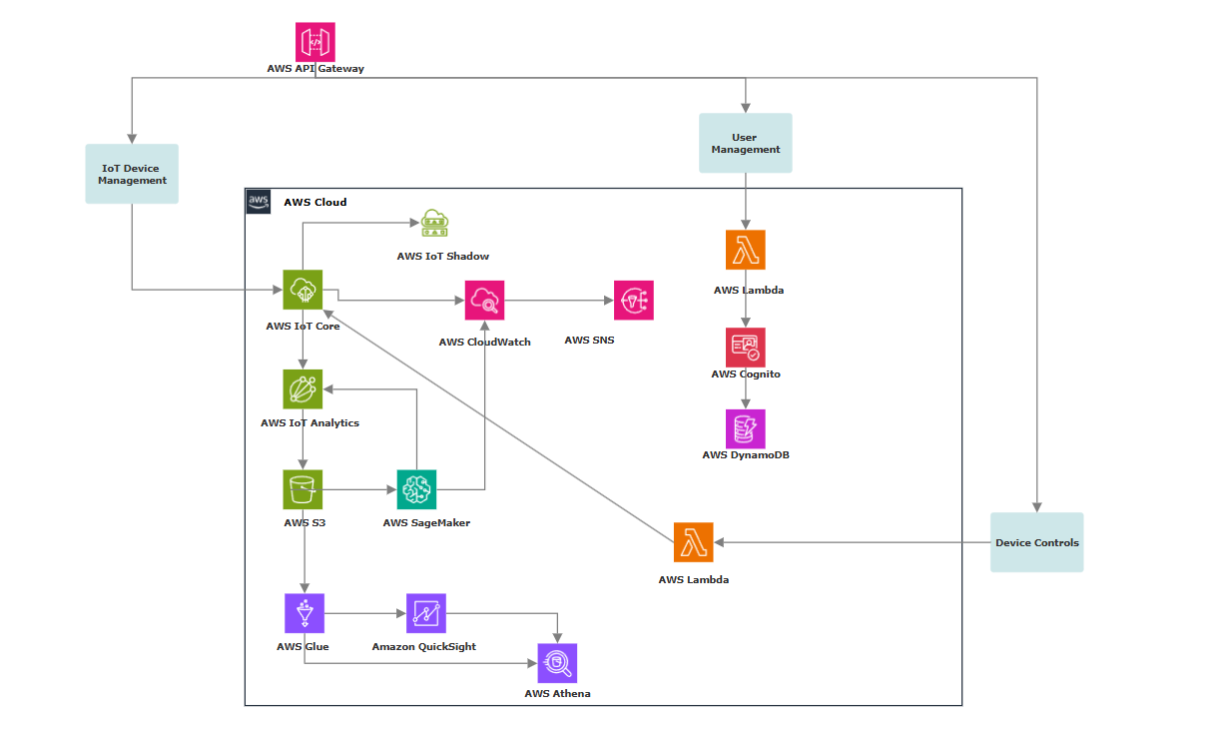

**AWS API Gateway:**

1. Backend Integration: Connects client apps to AWS services like Lambda, and DynamoDB.
2. Secure Access: Provides authentication, authorization, and access control using Cognito.

**User Management:**

AWS Lambda

1. User Operations: Handles custom user signup, login, and profile updates.
2. Cognito Integration: Triggers Lambda functions for Cognito events like authentication or post-confirmation.
3. Custom Logic: Implements advanced workflows, validations, and access policies for user management.

AWS Cognito

1. User Storage: Manages user data and authentication credentials.
2. DynamoDB Integration: Syncs and stores custom user attributes in DynamoDB.
3. Session Management: Provides secure token-based access to backend resources.

AWS DynamoDB

1. User Data Storage: Stores custom user attributes and session details linked to Cognito users.
2. Seamless Integration: Enables fast retrieval and updates of user-related data for authentication workflows.

**IoT Device Management:**

AWS IoT Core

1. Device Connectivity: Manages secure communication between IoT devices and AWS services.
2. Data Analytics: Streams device data to AWS IoT Analytics for insights and processing.

AWS IoT Analytics

1. Data Processing: Cleans, filters, and transforms raw IoT data for analysis.
2. Custom Pipelines: Supports custom processing pipelines for tailored data enrichment.
3. Processed Data Storage: Stores the cleaned and enriched data in S3 for long-term storage and access.

AWS S3

1. IoT Data Storage: Stores raw and processed IoT device data from AWS IoT Analytics in Amazon S3.
2. Machine Learning: Integrates with SageMaker to build and deploy predictive models for IoT data, such as anomaly detection or performance forecasting.
3. ~~ETL Processing: AWS Glue performs ETL on IoT data stored in S3, transforming it for use in analytics.~~

No Longer Suggested:

~~AWS Glue~~

1. ~~Data Transformation: AWS Glue extracts, transforms, and loads (ETL) data for analysis, preparing it for visualization.~~
2. ~~Seamless Integration: Transfers processed data to AWS QuickSight for easy visualization and reporting.~~
3. ~~Data Cataloging: AWS Glue Data Catalog serves as a centralized repository for QuickSight to query and visualize the transformed data.~~

~~AWS QuickSight~~

1. ~~Data Visualization: AWS QuickSight provides interactive dashboards and reports to visualize IoT data insights.~~
2. ~~Data Exploration: Allows users to explore and analyze IoT data with easy-to-use, drillable visualizations.~~
3. ~~Real-Time Insights: Offers real-time analytics by integrating with AWS services like S3, Glue, and IoT Analytics.~~

~~AWS Athena~~

1. ~~Data Querying: AWS Athena queries structured data stored in AWS Glue Data Catalog for efficient analysis.~~
2. ~~Seamless Integration: Integrates with AWS QuickSight for visualizing query results from Athena in interactive dashboards.~~
3. ~~Serverless Analytics: Provides serverless querying of large datasets without the need for infrastructure management.~~

AWS SageMaker

1. Model Training & Prediction: AWS SageMaker trains machine learning models on IoT data from S3 and IoT Analytics, generating predictions such as anomalies or performance issues.
2. Real-Time Predictions: Deployed models in SageMaker provide real-time predictions on incoming IoT data, enabling proactive decision-making.
3. Alerting Integration: SageMaker predictions trigger AWS ~~CloudWatch~~ IoT Events when thresholds are breached, sending email notifications via SNS to users for timely actions.

~~AWS CloudWatch~~

1. ~~Device Monitoring: AWS CloudWatch receives real-time data from AWS IoT Core, allowing you to monitor the health and status of connected IoT devices.~~
2. ~~Prediction Monitoring: CloudWatch captures prediction results from AWS SageMaker to track model performance and detect anomalies or potential issues.~~
3. ~~Alerts & Notifications: CloudWatch can trigger alarms based on IoT device metrics or SageMaker predictions, sending notifications via SNS to alert users when thresholds are exceeded.~~

AWS SNS

1. IoT Device Alerts: AWS SNS sends real-time notifications (email, SMS, etc.) when AWS IoT Core detects device health issues or exceeds defined thresholds, ensuring quick response.
2. Prediction Notifications: SNS delivers alerts about future predictions (e.g., anomalies or failures) made by SageMaker models, helping users act proactively.
3. Automated Communication: SNS enables automatic, scalable communication by integrating with ~~CloudWatch~~ AWS IoT Events, ensuring alerts are sent based on real-time device data or prediction outcomes.

**IoT Device Control:**

AWS Lambda

1. Real-Time Device Commands: AWS Lambda executes custom code in response to IoT device data or user input, sending control commands (e.g., turning devices on/off) to devices via AWS IoT Core.
2. Event-Driven Actions: Lambda triggers device actions based on IoT events or predictive analytics from SageMaker, automating responses like adjusting settings or configurations.

AWS IoT Core

1. Request Processing: AWS IoT Core processes incoming device control requests from AWS Lambda, ensuring secure communication between Lambda functions and IoT devices.
2. Device State Management: AWS IoT Device Shadow maintains the current state of devices, enabling Lambda to update or retrieve device status and control them accordingly.
3. Real-Time Device Control: IoT Core, combined with Device Shadows, allows Lambda to send real-time control commands, ensuring devices follow the required configurations or actions based on triggers.

AWS IoT Device Shadow

1. Device State Management: AWS IoT Device Shadow stores and retrieves the current state of IoT devices, allowing applications to interact with devices even when they are offline.
2. Real-Time Sync: Enables real-time synchronization of device states, ensuring devices reflect the latest configurations or changes from cloud-based commands.

**Updated Architecture:**

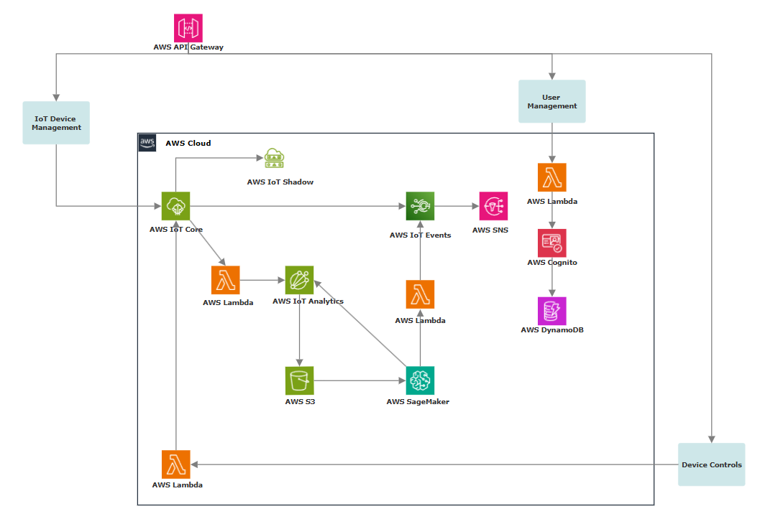

**1. Multitenancy Implementation:**

* **User Segmentation**: Use AWS Cognito for tenant-specific authentication and authorization. Assign custom attributes to users to identify their tenant.
* **Data Isolation**:
  + Use DynamoDB with tenant-specific partition keys to ensure logical data isolation.
* **Shared Resources**:
  + Use resource tagging to distinguish tenant-related resources (e.g., S3 buckets, IoT Core topics).
  + Leverage AWS Resource Access Manager (RAM) to share common services like SageMaker models.
* **Custom APIs**:
  + Design APIs with tenant IDs to process tenant-specific requests through API Gateway and Lambda.

**2. High Availability Across Multi-Geo Locations:**

* **Region Distribution**: Deploy resources like Lambda, DynamoDB, and IoT Core across multiple AWS regions.
* **Global Data Synchronization**:
  + Use DynamoDB Global Tables for replicating user and device data across regions.
  + Employ S3 cross-region replication for storing IoT data.
* **Monitoring**: Deploy CloudWatch metrics and alarms in each region to monitor application health and failover triggers.

1. **Steps for Cost Optimization:**

* **Removed Glue and Quicksight.**

Using AWS Lambda with IoT Analytics instead of Glue and Quicksight.

Cost Breakdown:

1. AWS Lambda:
   * Charged based on the number of invocations and execution time.
   * Cost-effective for small to medium-scale workloads as Lambda scales automatically and you only pay for what you use.
2. IoT Analytics:
   * S3: Storage costs for processed data; cheaper than Glue's managed catalog.
   * Data Set Queries: Charged per query and the amount of data queried.
   * Visualization: Built-in visualization tools in IoT Analytics.

**Cost Efficiency Comparison**

|  |  |  |
| --- | --- | --- |
| **Factor** | **Lambda + IoT Analytics** | **Glue + QuickSight** |
| **Initial Costs** | Lower (pay-per-use Lambda and IoT Analytics) | Higher (Glue DPUs and QuickSight fees) |
| **Data Volume** | More cost-effective for small to medium data | Scales better for large datasets |
| **Visualization Needs** | Basic charts (IoT Analytics built-in tools) | Advanced, customizable dashboards |
| **Processing Frequency** | Suitable for real-time or periodic updates | Better for batch ETL jobs |

* + - **Removed CloudWatch**

Replaced it by using AWS IoT Events and usage of Lambda to trigger AWS IoT Events for predicted alerts.

**Cost Efficiency Comparison**

|  |  |  |
| --- | --- | --- |
| **Aspect** | **CloudWatch** | **Lambda + IoT Events** |
| **Fixed Costs** | $0.30 per metric + $0.10 per alarm. | $0.20 per million evaluations  (IoT Events). |
| **Event Frequency**  **Impact** | Higher cost as alarms  increase. | Lower cost for high-frequency evaluations. |
| **Flexibility** | Simple alarms only. | Supports custom, event-driven workflows. |